Kimsey Memorial

Memorial for Mary, Rowan, and Stella Kimsey.
Lakeside Gardens

Lakeside Gardens
16211 SE Foster Rd
Portland, OR 97236

Saturday, September 26

Memorial Schedule
11:00 AM — Reception and light refreshments
12:00 PM — Memorial Service

Photos of Mary, Rowan, and Stella are greatly appreciated. It would be especially helpful if you could select a smaller collection of your favorite or most meaningful photos rather than sending a very large number. For example, choosing 10–30 of your favorites would be ideal.

Photos of Rowan’s artwork would also be very much appreciated.

Please send your favorite and most meaningful photos to kimseymemorialphotos@gmail.com

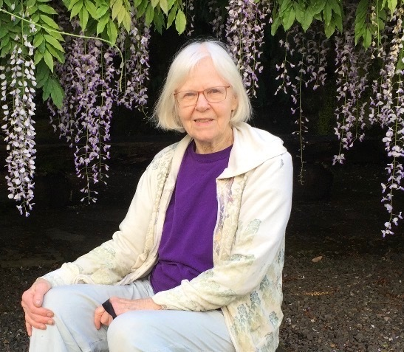

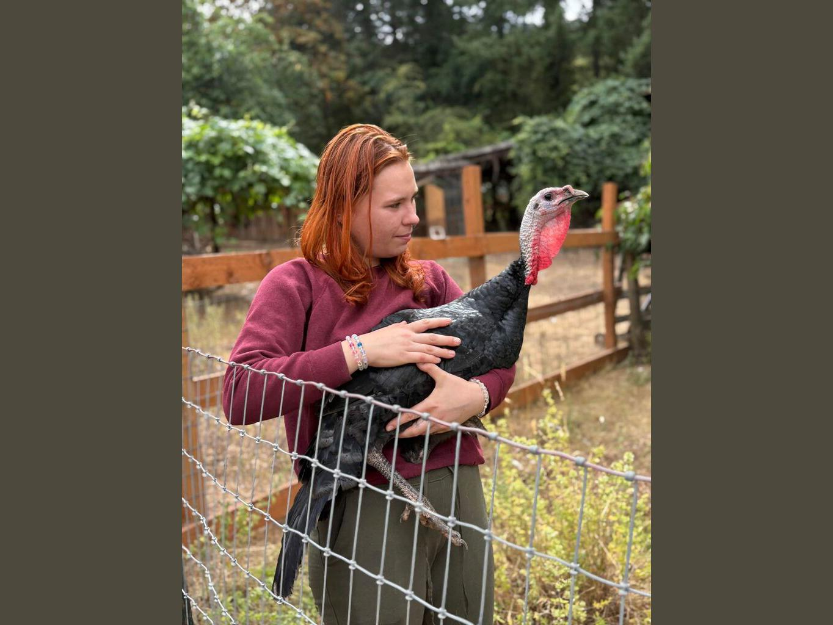

Travel and Accommodations:
Portland International Airport (PDX) is the region's main airport and is located about 12 miles (19 km) from downtown Portland. The MAX Red Line light rail provides direct service between PDX and downtown Portland in approximately 38 minutes.
Getting to the Lakeside Gardens: From Portland International Airport (PDX)
MAX Light Rail + Bus
- Take the MAX Red Line from PDX toward downtown/Beaverton.
- Transfer to a TriMet bus serving the serving the SE Foster Road area.

A few Hotel Options
Canopy by Hilton
https://www.hilton.com/en/brands/canopy-by-hilton/
The Benson Portland, Curio Collection by Hilton
https://www.hilton.com/en/hotels/pdxbeqq-the-benson-portland/
Residence Inn by Marriott Portland Downtown/Pearl District
https://www.marriott.com/en-us/hotels/pdxpd-residence-inn-portland-downtown-pearl-district/overview/
Dossier Hotel
https://www.dossierhotel.com/
DoubleTree by Hilton Hotel Portland
https://www.hilton.com/en/hotels/rllc-dt-doubletree-portland/?SEO_id=GMB-AMER-DT-RLLCDT
Hotel deLuxe
https://www.hoteldeluxe.com/
Hotel Lucia
https://www.hotellucia.com/
Embassy Suites by Hilton Portland Downtown
https://www.hilton.com/en/hotels/pdxpses-embassy-suites-portland-downtown/?SEO_id=GMB-AMER-ES-PDXPSES

